**Circuit Diagram & Truth Table:**

|  |  |  |  |
| --- | --- | --- | --- |
| **CLK** | **D** | **Q** | **Q’** |
| 0 | 0 | 1 | 0 |
| 1 | 0 | 0 | 1 |
| 0 | 1 | 0 | 1 |
| 1 | 1 | 1 | 0 |

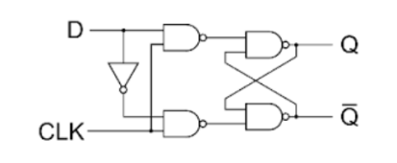

**Code:**

* **Design Module**

module dff(q,qb,d,clk);

input d,clk;

output q,qb;

wire a,b,dbar;

assign dbar=~d;

assign a=~(d&clk);

assign b=~(dbar&clk);

assign q=~(a&qb);

assign qb=~(b&q);

endmodule

* **TestBench**

module Baig;

reg d,clk;

wire q,qb;

dff dffff(q,qb,d,clk);

initial

begin

d=1'b0;clk=1'b0;

#20

d=1'b0;clk=1'b1;

#20

d=1'b1;clk=1'b0;

#20

d=1'b1;clk=1'b1;

#20

$finish;

end

endmodule

**Output:**

